DESC branch

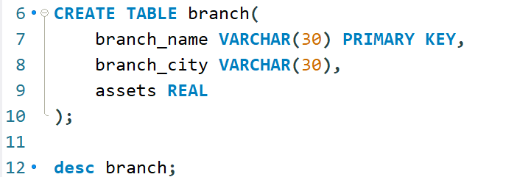

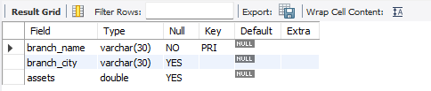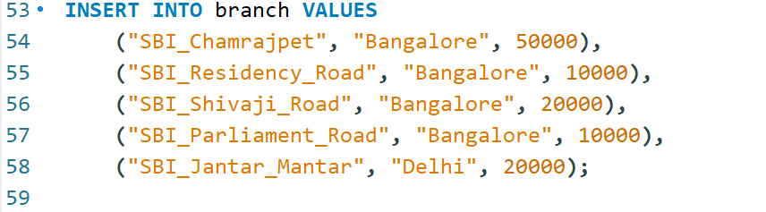

DESC bank_account

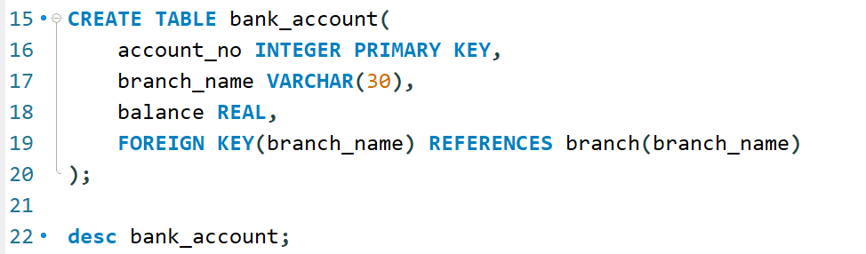

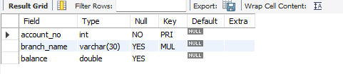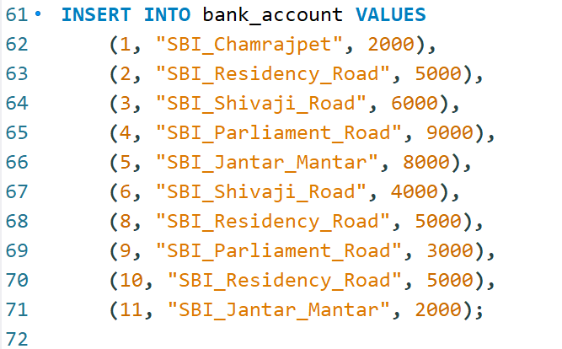

DESC bank_customer

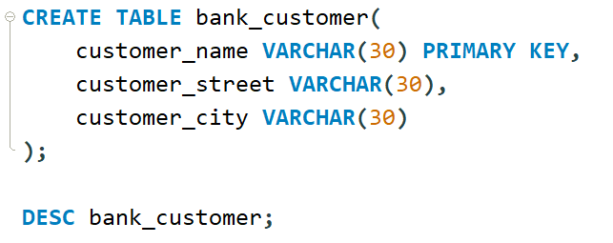

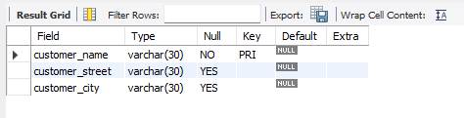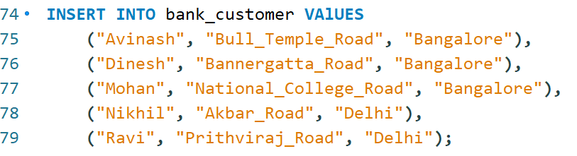

DESC depositor

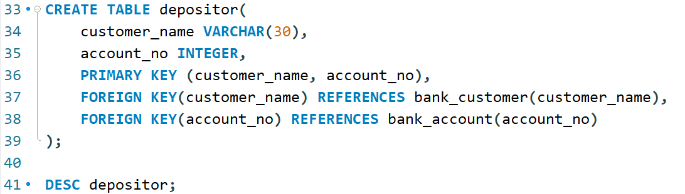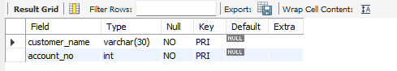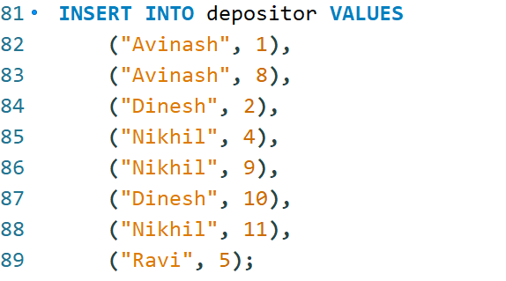

DESC loan;

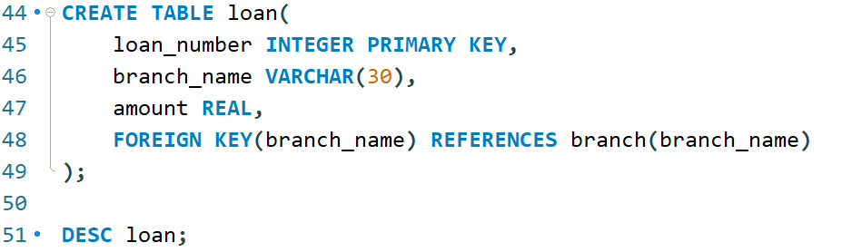

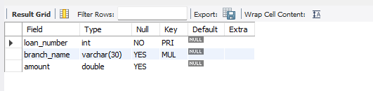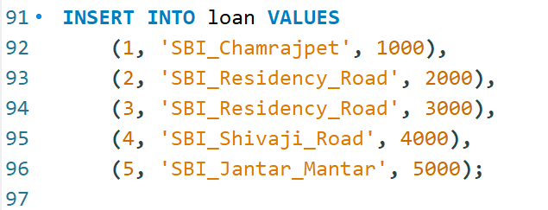

**QUERY 3**

**Find all the customers who have atleast two deposits at the same branch**

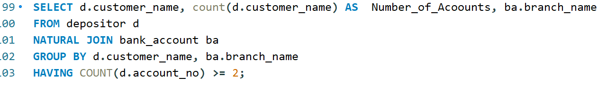

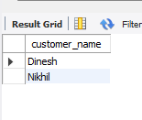

**QUERY 4**

**Find all the customers who have an account at all the branches located in specific city ex: Delhi**

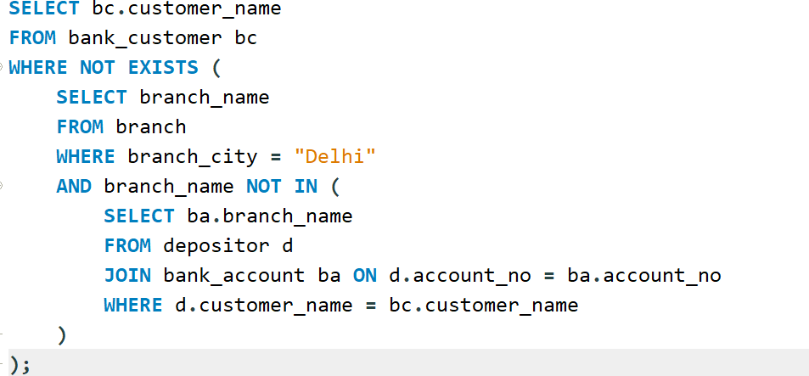

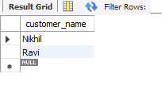

**QUERY 5**

**Demonstrate how you delete all the account tuples at a branch located at ex: Shivaji Road**

